**Chapter 1. The Wireless Channel: Propagation and Fading**

The performance of wireless communication systems is mainly governed by the wireless channel environment.

- 무선 통신 시스템에서 **성능**은 주로 **무선 통신 채널 환경**에 영향을 받는다.

- 실제로 석사 과정에서 진행한 연구는 "하나의 전파 채널(**Propagation Channel**)을 주파수 영역에서 멀리 분리된 두 대역에서 동시에 사용할 때, 한 대역에서 송수신한 파일럿으로 다른 대역의 전파(**Radio Channel**)채널을 추정하는 방식"을 연구 및 실측을 한 것 이였다. 이를 위해 MIMO 송수신기를 FDD 방식으로 서로 다른 중심주파수를 가진 신호를 송수신하였고, 결과적으로 추정한 결과를 통해, Power Delay Profile(PDP), Frequency Response, Channel Magnitude Response 등을 활용했다. - 해당 연구 결과가 가능했던 이유는 결국, 연구 측정 환경이 포스텍의 LG연구동이라는 실내인 ergodic하며, stationary한 환경 이였기 때문이다. 즉, 무선 통신 시스템에서 성능은 무선 통신 채널에 많은 영향을 끼친다.

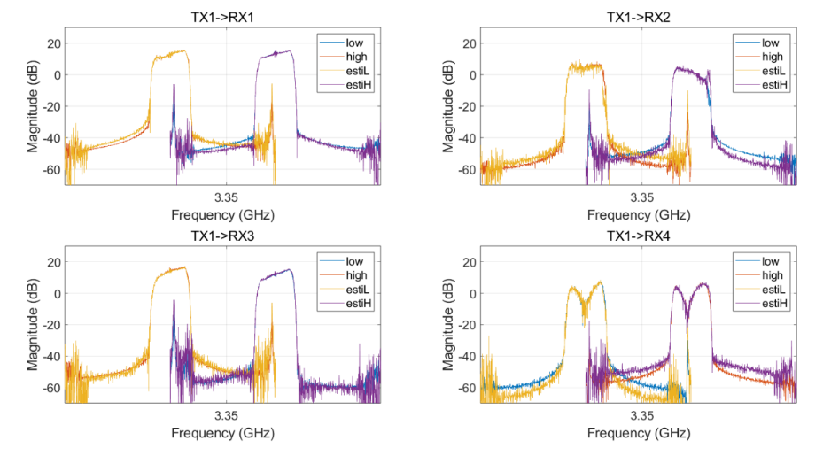

In wireless communication, radio propagation refers to the behavior of radio waves when they are propagated from transmitter to receiver. In the course of propagation, radio waves are mainly affected by three different modes of physical phenomena: - reflection, diffraction, and scattering.

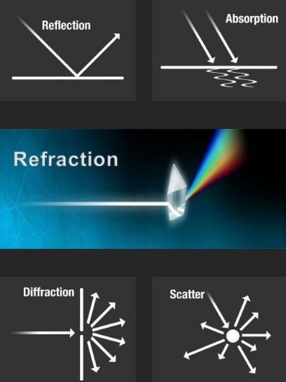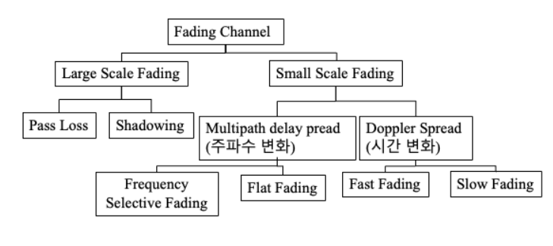

출처: [https://velog.io/@hsshin0602/%ED%86%B5%EC%8B%A0-%EC%9D%B4%EB%A1%A0-%ED%8E%98%EC%9](https://velog.io/@hsshin0602/%ED%86%B5%EC%8B%A0-%EC%9D%B4%EB%A1%A0-%ED%8E%98%EC%259)  
D%B4%EB%94%A9fading%EC%9D%98-%EC%9C%A0%ED%98%95

**<Classification of fading channels>**

The fading phenomenon can be broadly classified into two different types: large-scale fading and small-scale fading.

Doppler Spread: Time variance

- Depending on the time variation in a channel due to mobile speed (characterized by the Doppler spread), short-term fading can be classified as either fast fading or slow fading.

- **slow fading**: 기지국과 이동국이 멀어지는 경우, 도플러 효과에 의해 수신신호 주파수가 낮아지는 현상.

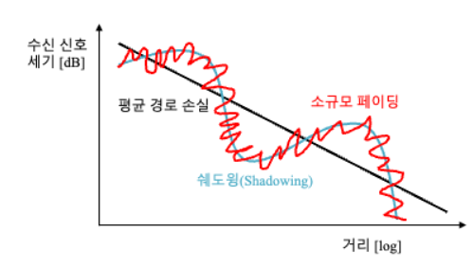

위의 그림은 소규모 페이딩과 대규모 페이딩의 차이를 보여주고 있다.

The relationship between large-scale fading and small-scale fading is illustrated in Figure.

* 1. **Large-Scale Fading**

**1.1.1 General Path Loss Model**

The free-space propagation model is used for predicting the received signal strength in the line-of-sight(LOS) environment where there is no obstacle between the transmitter and receiver.

$$P_{r}\left(d\right)=\frac{P_{t}G_{t}G_{r}λ^{2}}{{\left(4π\right)}^{2}d^{2}L}$$

d=distance in meters between the transmitter and receiver.

$P_{t}$ =transmit power(watts), L=the system loss factor which is independent of propagation environment.

When non-isotropic antennas are used with a transmit gain of $G_{t}$ and a receive gain of $G_{r}$, the received power at distance d, $P_{r}(d)$ is expressed by the well-known Friis equation.

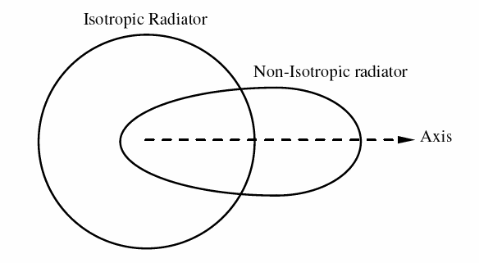

A log-normal shadowing model is useful when dealing with a more realistic situation.

$X_{σ}$ =Gaussian random variable with a zero mean and a standard deviation of $σ$.

Log-normal shadowing model

PL(d)[dB]= $\overline{PL}\left(d\right)+X_{σ}=PL_{F}\left(d_{0}\right)+10nlog\left(\frac{d}{d_{0}}\right)+X_{σ}$

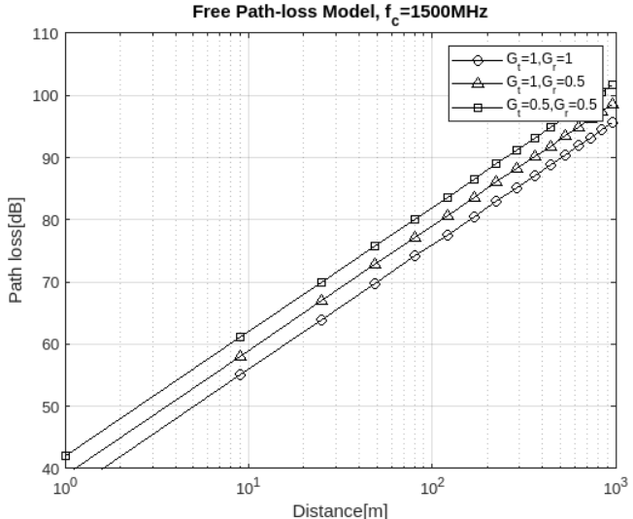

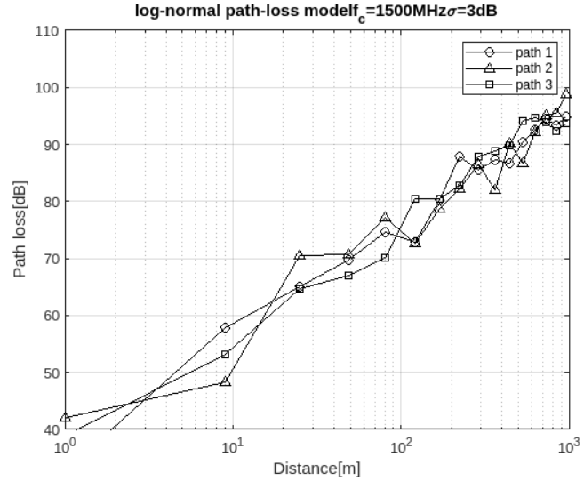

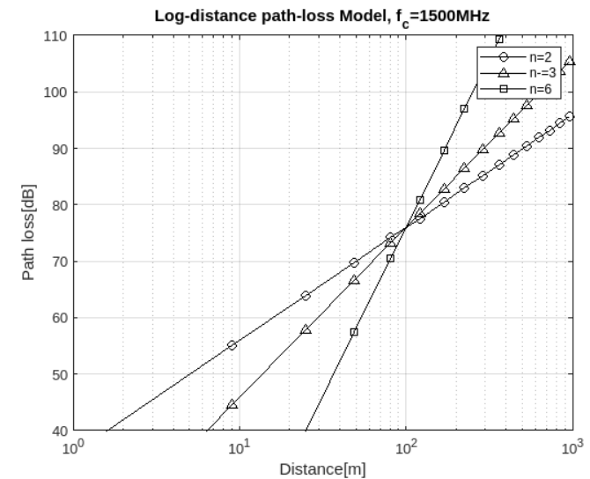

**1.1.2 Okumura/Hata Model**

The Okumura model has been obtained through extensive experiments to compute the antenna height and coverage area for mobile communication systems. It is one of the most frequently adopted path loss models that can predict path loss in an urban area.

$$PL_{Ok}\left(d\right)\left[dB\right]=PL_{F}+A_{MU}\left(f,d\right)-G_{RX}-G_{TX}+G_{AREA}$$

$A_{MU}\left(f,d\right)$: the medium attenuation factor at frequency f

$G_{TX},G_{RX}$: antenna gains of TX and RX antennas, $G_{AREA}$: the gain for the propagation environment in the specific area.

The Okumura model has been extended to cover the various propagation environments including urban, suburban and open area, which is now know as the Hata model.

* Mainly covers the typical mobile communication system characteristics with a frequency band of 500 ~ 1500 MHz, cell radius of 1~100km, and an antenna height of 30~100m.

- it is clear that the urban area gives the most significant path loss as compared to the other areas, simply due to the dense obstructions observed in the urban area.

* + 1. **IEEE 802.16d model**

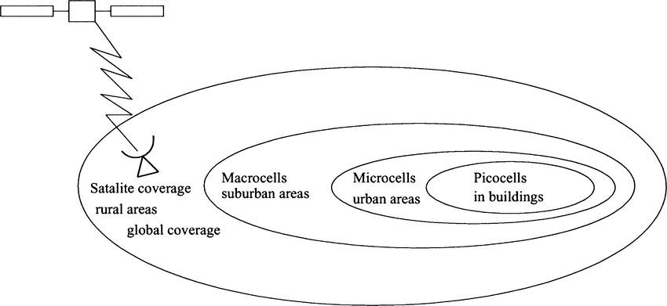

IEEE 802.16d model is based on the log-normal shadowing path loss model.

$$P_{802.16}\left(d\right)\left[dB\right]=PL_{F}\left(d_{0}\right)+10γ\log_{10}\left({\frac{d}{d}}_{0}\right)+C_{f}+C_{RX},for d>d_{0}$$

Types of models (type A, B, C), depending on the density of obstruction between the transmitter and receiver in a macro-cell suburban area.

$C_{RX}$: correlation coefficient for the receive antenna

* When the height of the transmit antenna is changed from 2m to 10m, there is a discontinuity at the distance of 100m, causing some inconsistency in the prediction of the path loss. -> $d_{0}$ 인 100m를 기준으로 송, 수신 안테나 간의 거리가 100m를 넘어가면 path loss가 연속적이지 않은 상태로 증가하기에, $d_{0}$ 를 개선한 ${d'}_{0}$ 를 만든다.

$$20\log_{10}\left(\frac{4πd_{0}^{'}}{λ}\right)=20\log_{10}\left(\frac{4πd_{0}^{'}}{λ}\right)+10γlog⁡_10(\frac{d_{0}^{'}}{d})+C_{f}+C_{RX}$$

$20\log_{10}\left(\frac{4πd_{0}^{'}}{λ}\right)$: $G_{t}=G_{r}=1$ 일 때, free space path model: $PL_{F}\left(d\right)=20\log_{10}\left(\frac{4πd}{λ}\right)$

$${d'}_{0}=d_{0}^{-\frac{C_{f}+C_{RX}}{10γ}}$$

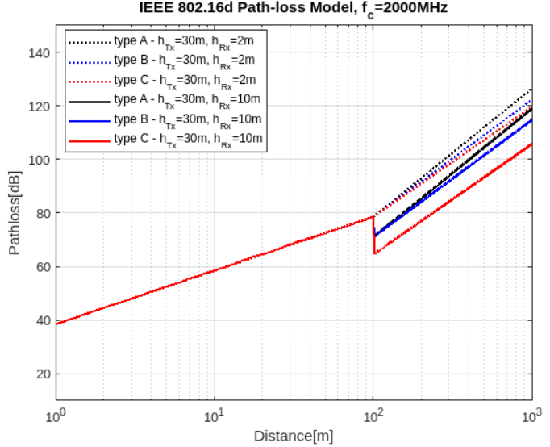

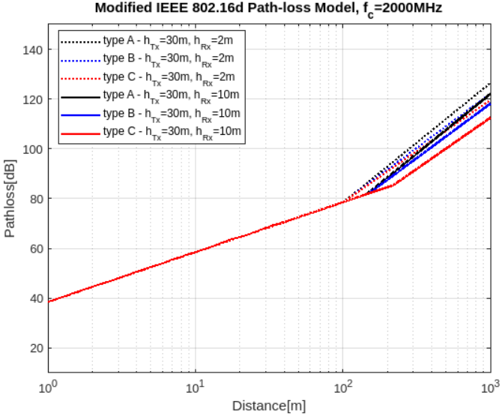

**1.2 Small-Scale Fading**

Unless confused with large-scale fading, small-scale fading is often referred to as fading in short.

- Small-Scale Fading: 다중 경로에 의해 생기는 fading의 총칭으로, 무선 이동 단말이 좁은 지역에서 이동할 때 수신 신호 세기의 급격한 변동을 의미한다.

- Fading (Small-Scale Fading) is the rapid variation of the received signal level in the short term as the user terminal moves a short distance. It is due to the effect of multiple signal paths, which cause interference when they arrive subsequently in the receive antenna with varying phases.

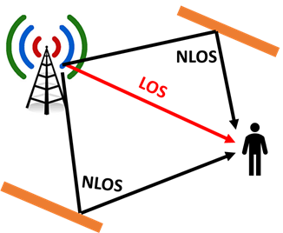

In other words, the variation of the received signal level depends on the relationships of the relative phases among the number of signals reflected from the local scatters.

- In summary, small-scale fading is attributed to **multi-path propagation**, **mobile speed**, **speed of surrounding objects**, and **transmission bandwidth of signal**.

1.2.1 Parameters for Small-Scale Fading

Characteristics of a multipaths fading channel are often specified by a power delay profile (PDP).

다중 경로 fading의 특징은 PDP에 의해 결정되어 지고, 이때 relative delay, average power 등의 파라미터로 채널의 특징을 분석한다.

The relative delay is an excess delay with respect to the reference time while average power for each path is normalized by that of the first path.

Mean excess delay and RMS delay spread are useful channel parameters that provide a reference of comparison among the different multipath fading channels, and furthermore, show a general guideline to design a wireless transmission system.

- 다중 경로에 의해 채널 특성은 다양하게 변화하는 데, 이 특징들을 파악하기 위해서 Mean excess delay, RMS delay spread 등을 통해 파악한다. 해당 값들은 석사 시절 채널 추정 연구를 진행할 때 서로 다른 주파수 대역 $f_{1},f_{2}$ 가 있을 때, $f_{1}$ 의 채널 값으로 $f_{2}$ 의 채널을 예측한 다음 그 값과 실제 $f_{2}$ 의 채널 값을 비교할 때, 채널의 특성을 파악할 수 있는 파라미터인 Mean excess delay, RMS delay spread 등을 활용하였다.

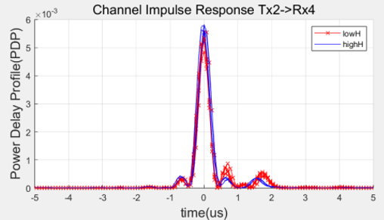

$τ_{k}$: channel delay of the kth, $a_{k},P(τ_{k})$: amplitude and power.

**Mean excess delay $$\overline{τ}=\frac{\sum_{k}{a_{k}^{2}τ_{k}}}{\sum_{k}{a_{k}^{2}}}$$ RMS delay spread $$σ_{τ}=\sqrt{\overline{τ^{2}}-{\left(\overline{τ}\right)}^{2}}$$**

**Coherence bandwidth $$B_{c}≈\frac{1}{σ_{τ}}$$**

**1.2.2 Time-Dispersive vs Frequency-Dispersive Fading**

As mobile terminal moves, the specific type of fading for the corresponding receiver depends on both the transmission scheme and channel characteristics.

- 이동 단말기가 이동할 때, 전송 방식과 채널 특성에 따라 수신기에 대한 fading의 종류가 달라지는데, 전송 방식은 신호의 대역폭과 심볼 주기에 의해 구체화되고, 무선 채널은 multipath delay spread와 doppler spread에 의해 특징화 되어진다.

**1.2.2.1 Fading Due to Time Dispersion: Frequency-selective Fading channel**

Due to time dispersion, a transmit signal may undergo fading over a frequency domain either in a selective or non-selective manner, which is referred to as frequency-selective fading or frequency non-selective fading, respectively.

**1.2.2.2 Fading Due to Frequency Dispersion: Time-Selective Fading Channel**

- fast/slow fading: Doppler spread

+)

2024.03.13: 해당 내용을 대략적으로 알았지만, 정리를 하려고 정확하게 이해하는 데 어려움이 있었습니다.

그림과 수식으로 해석한 후 완벽하게 이해를 하였습니다.

Small-Scale Fading은 해당 책에서는 소분류로, multipath fading, time variance라고 분류를 하는데, 다른 자료에서는 time variance를 doppler effect로 분류합니다.

결국 Small-Scale Fading은 좁은 지역 및 짧은 시간동안 신호 강도 및 위상이 급격하게 바뀌는 현상을 말합니다.

이때, Multipath delay spread는 time dispersion과 관련된 개념이고, Doppler spread는 frequency dispersion과 관련된 개념입니다.

이때 Fading Due to Frequency Dispersion: Time-Selective Fading Channel의 경우, 결국 Frequency Dispersion이니까 Doppler spread와 관련된 개념으로 Fast/Slow Fading로 세부 분류를 할 수 있습니다.

Fast Fading의 경우, $T_{s}$: symbol period of the transmit signal(전송 신호의 심볼 주기), $σ_{τ}$: RMS delay spread, $B_{d}$: Bandwidth of Doppler spectrum, $B_{s}$: bandwidth of the transmit signal로 정의할 수 있는데, $T_{s}>T_{c}, B_{s}<B_{d}$ 의 조건을 갖는다.

즉, Time domain에서 $T_{s}>T_{c}$ 을 통해, 전송신호의 주기보다 coherence time값이 길어서, 채널의 특성이 빠르게 변하고, 그로 인해 짧은 시간 간격으로 측정된 신호의 주파수 변화가 커진다는 것이며, $B_{s}<B_{d}$ 의 경우 Frequency Domain이니까 반대의 개념으로 생각했고, 그러기 때문에, $T_{c}≈\frac{1}{f_{m}}$.

1.2.2의 마지막 문구에

It is important to note that fast or slow fading does not have anything to do with time dispersion-induced fading. In other words, the frequency selectivity of the wireless channel cannot be judged merely from the channel characteristics of fast or slow fading. This is simply because fast fading is attributed only to the rate of channel variation due to the terminal movement.

즉 앞서 언급했던 것처럼 fast/slow fading의 경우, frequency dispersion과 관련된 개념이기 때문에, time-dispersion-induced fading과 관련이 없고, fast fading은 단지 terminal의 움직임에 의한 채널의 변화속도만을 나타내기 때문이라고 설명하고 있다.

**1.2.3 Statistical Characterization and Generation of Fading Channel**

**1.2.3.1 Statistical Characterization of Fading Channel**

In Clarke’s proposed model, there are N planewaves with arbitrary carrier phases, each coming from an arbitrary direction under the assumption that each planewave has the same average power.

$x(t)$: baseband transmit signal. Passing through a scatter channel of different propagation paths with different I Doppler shift, the passband received signal can be represented as $$\tilde{y}\left(t\right)=Re\left[\sum_{i=1}^{I}{C_{i}}e^{j2π\left(f_{i}+f_{c}\right)\left(t-τ_{i}\right)}x\left(t-τ_{i}\right)\right]=Re[y\left(t\right)e^{j2πf_{c}t}]$$

$C_{i}$: channel gain, $τ_{i}$: delay, $f_{i}$: Doppler shift for the $i$ th propagation path.

$v$: mobile speed, $λ$: wave length,

Doppler shift $f_{i}=f_{m}cosθ_{i}=\frac{v}{λ}cosθ_{i}, f_{m}$: maximum Doppler shift, $θ_{i}$: angle of arrival (AOA) for the $i$ th planewave.

The power spectrum density (PDS) of the fading process is found by the Fourier transform of the autocorrelation function of $\tilde{y}(t)$: **Classical Doppler Spectrum $$S_{\tilde{y}\tilde{y}}\left(f\right)=\left\{\begin{aligned}\frac{Ω_{p}}{4πf_{m}}\frac{1}{\sqrt{1-{\left(\frac{f-f_{c}}{f_{m}}\right)}^{2}}},|f-f_{c}|≤f_{m} \\ 0, otherwise\end{aligned}\right.$$**

$$Ω_{p}=E\left\{h_{I}^{2}\left(t\right)\right\}+E\left\{h_{Q}^{2}\left(t\right)\right\}=\sum_{i=1}^{I}{C_{i}^{2}}$$

If some of the scattering components are much stronger than most of the components, the fading process no longer follows the Rayleigh distribution. -> Rician distribution.

**1.2.3.2 Generation of Fading Channels**

In general, the propagation environment for any wireless channel in either indoor or outdoor may be subject to LOS or NLOS.

PDF of signal received in the LOS environment follows Rician distribution, while that in that in the NLOS environment follows the Rayleigth distribution.

* **LOS: Rician distribution**
* **NLOS: Rayleigh distribution**

By the central limit theorem, the received signal can be represented by a Gaussian random variable. In other words, a wireless channel subject to the fading environments can be represented by a complex Gaussian random variable, $W_{1}+jW_{2},$ where $W_{1}$ and $W_{2}$ are the independent and identically-distributed (i.i.d) Gaussian random variable $W_{1}+jW_{2}$, such that $X=\sqrt{W_{1}^{2}+W_{2}^{2}}$. Then, note that X is a Rayleigh random variable with the following probability density function (PDF): $$f_{X}\left(x\right)=\frac{x}{σ^{2}}e^{-\frac{x^{2}}{{2σ}^{2}}}$$ 
where ${2σ}^{2}=E\{X^{2}\}$. Furthermore, $X^{2}$ is known as a chi-square random variable.

Note that the Rayleigh random variable X with the PDF can be represented by $X=σ\sqrt{Z_{1}^{2}+Z_{2}^{2}}$ where $Z_{1}\sim N(0,1)$ and $Z_{2}\sim N(0,1)$. Once $Z_{1}$ and $Z_{2}$ are generated by the built in-function “randn”, the Rayleigh random variable X with the average power of $E\left\{X^{2}\right\}=2σ^{2}$ can be generated by $X=σ\sqrt{Z_{1}^{2}+Z_{2}^{2}}$.

